ANNEX C – GUIDELINES FOR APPLICANTS AND PROPOSAL FORM
- DEFINITIONS
Applicant | Research staff constituting the proponent team
Project Leader | Organisation coordinating the project proposal
Project Partner | Organisation participating in the project proposal
Principal Investigator (PI) | Main representative of each organisation participating in the project proposal, either as Project or as Project Partner
Research Infrastructure’s Provider | Organisation offering access to its own Research Infrastructure in the TA Call
Rolling Call | A call where a project proposal can be submitted any time but evaluated after the first deadline following the submission date.
Team Member (or User Team) | Staff of the Project Leaders and Project Partners involved in the project proposal
Call cut-off | In the Rolling Call scheme, the periodic deadline after which a submitted project proposals enters in the eligibility and evaluation phases. Proposals submitted in between two call cut-offs are evaluated once the second cut-off date is passed; proposals submitted after a cut-off are automatically considered after the next cut-off.
Window | The defined period within the Rolling Call during which proposals shall be implemented, corresponding to an indicative access schedule.

GENERAL GUIDANCE FOR ALL APPLICANTS

- The Call Text and its Annexes are available for downloading from the Sustainable Blue Economy Partnership project website page https://bluepartnership.eu/funding-opportunity/sustainable-blue-economy-partnership-transnational-access-call-research;
- The direct link to the submission platform is https://proposals.etag.ee/sbep-ris/2026 and the technical help desk is: epss.sbep-ris@g.etag.ee;
- The PI of the Project Leader shall create an account and log in the EPSS to provide the information required for the participation (Fig.1a).
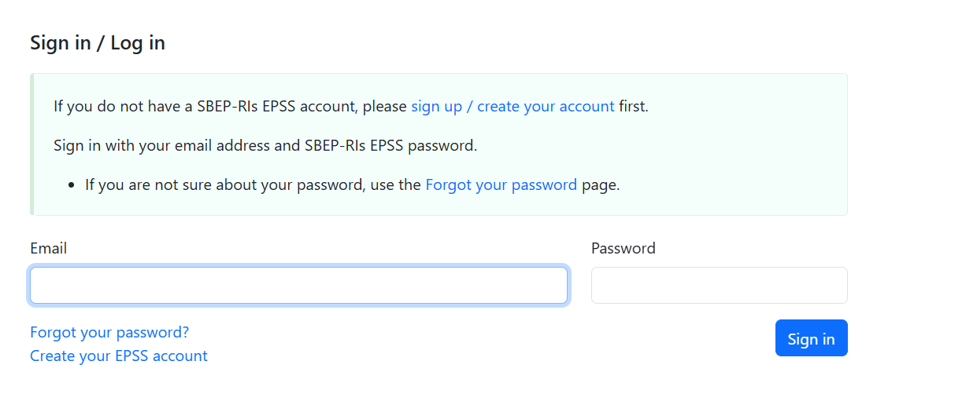
- The PI of the Project Leader is the Partner 1 of the proposal (). The PI of the Partner 1 shall create a project proposal (Fig. 1b).
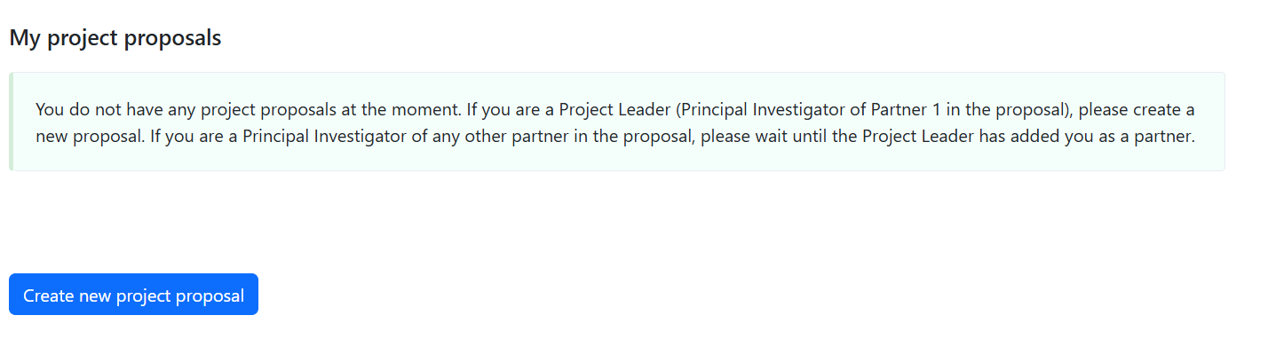
Fig. 1a-b: Relevant samples from the EPSS platform: sign-in by the PI and creation of a project proposal.

- Before the proposal submission, the PI of the Project Leader shall get in touch with the provider of the desired RI(s) (check Annex A for the list of contacts), to explain the general idea of the proposal, get technical details on the use of the RI and draft a sound and really feasible proposal.
- The applicants shall demonstrate the availability of their own funding to conduct the activities. SBEP offers access to RIs but does not support any expenses incurred by the applicants.
- The submission form is composed by four parts (Fig. 2):

  - Part A – GENERAL PROJECT INFORMATION
  - Part B – PROJECT DESCRIPTION
  - Part C – ADMINISTRATIVE DETAILS AND DECLARATION OF BUDGET AVAILABILITY OF PROJECT LEADER AND PARTNERS, AND CURRICULUM VITAE OF THE PROJECT LEADER’S PI
  - Part D – ADDITIONAL INFORMATION.
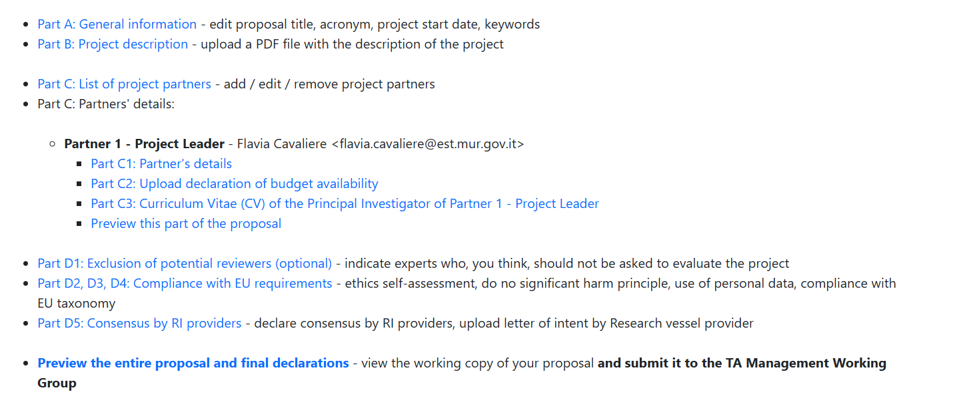
- . The different parts of the proposal, written in English, should not exceed the prescribed maximum length. Incomplete proposals will be rejected and will not be evaluated.
- Any documents other than those requested as part of the proposal will not be forwarded to the International Evaluation Panel (IEP) members, including letter(s) of support.
The proposals can be submitted any time during the period of the Rolling Call by the PI of the Project Leader, who is responsible for the accuracy and completeness of all the information provided at the time of submission.
- The PI of the Project Leader is allowed to upload one or more draft of the proposal on EPSS. However, only the most recent version of a proposal uploaded before the cut-off will be considered by the TA Management Working Group (TA Mgmt WG).
- Once the cut-off date has passed, it will no longer be possible to edit or resubmit the proposal until the next cut-off of the Rolling Call.

PROPOSAL PART A - GENERAL PROJECT INFORMATION

Part A must be filled directly on the EPSS by the Principal Investigator of Partner 1 (Project Leader).

PROJECT ID = GENERAL AND LOGISTICAL PROJECT INFORMATION
(*) mandatory
CALL ID: | SBEP2025RIs
Proposal ID: | Automatically from EPSS  (e.g. SBEP2025RIs-1)
Project title (*)  (max 255 characters including spaces) | Please note that the project title shall not be changeable.
Short name / Acronym (*)  (max 20 characters including spaces) | Please note that the acronym shall be considered as definitive
Selected SRIA’s objective(s) (*) | Indicate one or more of the following options:  Pillar 1 – A blue economy in harmony with nature  - Enhancing the scientific basis for the sustainable use of living and non-living marine resources.  - Fostering collaboration with the private sector and industry to understand their capacity, needs, and trade-offs for increased pressures from use and multiuse of the ocean and seas in the face of a changing climate and associated extreme events, e.g. in relation to port developments, dredging, and maritime security.  - Introducing innovative technological and circular developments, which follow the ‘Rethink, Refuse, Reduce, Reuse, Recycle, Repair’ principle (e.g. in R&I of materials).  - Nature-based Solutions (NbS) for sustainable use and protection of marine ecosystems against eutrophication, harmful algal blooms (HAB), non-indigenous species, hazardous substances, litter, introduction of anthropogenic energy (underwater noise, light), overfishing, and physical damage to benthic and pelagic habitats, thereby restoring biodiversity.  - Improving the monitoring of the health of our ocean and seas in concordance with the Marine Strategy Framework Directive (MSFD; Good Environmental Status criteria, GES) requirements of the assessment and predictable frameworks for the industry. Better understanding of (cumulative) impacts of (blue) economic activities from shallow areas to the deep sea in all European seas to improve effectiveness of measures.  - Contributing to understanding and quantifying the ecosystem responses to climate change and direct and indirect anthropogenic pressures on the European sea basins at relevant spatial and temporal scales and in line with the specific requirements of the MSFD assessment framework, e.g. further development of existing and new indicators and related reference and threshold values forming baselines for activities at sea.  - Delivering FAIR data (including socioeconomic and socioecological) and science-based recommendations for coherent ecosystem-based management, including Marine Protected Areas (MPAs), Maritime Spatial Planning (MSP) and multi-use of marine spaces.  - Contributing to the development of tools to support maritime spatial planning (MSP), such as sensitivity mapping or modelling of cumulative impacts.  - Promoting standardisation in innovation and procurement processes to scale up the application of new solutions at higher Technology Readiness Levels (TRL).  - Enhancing and optimising the cost-benefit ratio of ocean and seas’ modelling and observation capacities, including fostering the development of sensors, sensor networks and marine robotics, as well as by means of artificial intelligence (AI) and machine learning tools. This will include advancing digital twin technologies and supporting the European Digital Twin of the Ocean (EDITO) initiative.  - Contributing concretely to alignment of national efforts to strengthen activities along the ocean observation value chain and data management and avoid duplication and fragmentation, including innovative governance concepts, e.g. demonstrating the value of ocean observation to society and removal of outdated regulations blocking transformation.  Pillar 2 – Blue economy solutions towards climate neutrality  - Developing marine Nature-based Solutions (NbS) to improve resilience to natural disasters, increase natural capital, and restore ecosystems.  - Fostering the carbon sequestration capacity and resilience of coastal and marine environments (‘blue carbon’), including related management actions and preventing carbon seepage to the atmosphere caused by humans.  - Supporting knowledge production and evidence-based recommendations for ocean and coastal resilience by quantifying at regional-scale and across basins the impacts of climate change and related stressors.  - Supporting inventions for upscaling innovation in the renewable ocean energy sector (e.g. wind, wave and tidal energy) and focusing on solutions that reduce the use of energy, materials, and other resources and the impact on marine life.  - Enabling novel materials and technologies for sustainable manufacturing and product lifecycle management.  - Developing sustainable and cost-efficient solutions for construction, maintenance, reuse of multi-use offshore platforms.  - Designing green and smart ports, blue marinas and transport.  - Contributing to innovative and sustainable concepts for small- and medium-sized vessels and recreational boating.  Pillar 3 – A thriving blue economy for the people  - Promote efficient and sustainable use of bioresources through biotechnology, AI, machine learning, digital twins and ICT. This includes value chain co-development and optimisation within the blue bioeconomy and biotechnology to reduce waste and ensure safe, healthy, affordable, and traceable products within a circular economy.  - Enhance safety and efficiency in maritime operations by advancing autonomous technologies for offshore operations, including underwater deployment and maintenance while reducing risks for humans and the environment.  - Encourage product and process innovation and exploration of low trophic level bioresources, innovate sustainable seafood production systems, including offshore, closed, low- and multi-trophic aquaculture, and low impact sustainable fisheries.  - Strengthen resilience of coastal communities and sectors through preparedness for climatic, geological, and anthropogenic hazards, while analysing community needs, building diverse employment opportunities, and formulating sustainable tourism models valuing coastal and maritime heritage.  - Promote human health and safety by generating knowledge that helps mitigate risks from marine-borne pathogens, toxins, harmful algae, toxicants, and pollutants.  - Ensure equitable benefit-sharing in marine activities, including biodiscovery.  - Explore and harness the potential of blue spaces and economies to improve the health and well-being of diverse communities, ensuring equitable access and benefits.  - Foster equity from innovation, circularity, and job creation in coastal communities.  - Foster a community of practice (CoP) for knowledge sharing and co-creation of skills on advancing the sustainable blue economy.  - Promote financial instruments for inclusion (especially for disadvantaged/marginalized groups) and transparency, while ensuring accountability of key actors.
Main Research Infrastructure (*)  (The main infrastructure is necessary and essential to develop the core of the proposal) | Indicate one infrastructure in the following categories:  - Research Vessels  - Fixed platforms, auxiliary devices and experimental stations  - Mobile platforms (AUVs, gliders, aircraft)  - Portable equipment  - Analytical labs and Test benches (pressure chambers, pools. calibration/inter-calibration bench, including sample analysis)  - Digital Facilities (high Performance Computing Infrastructures, data centres, satellite communication stations)  .  PI of the Project Leader shall contact the RI provider before the submission to verify the feasibility of the proposal(see key contact persons on Annex A to the TA Call Text).
Typology of access to main infrastructure (*) | Select one typology of access to main infrastructure:  - Remote: the requested facility is operated by the owner’s staff, and the presence of the user team is not required. Please check with the RI provider whether partially remote access is also enabled.  - Physical (In person/hands-on): the presence of the user team is required/recommended during the whole operation period  - Virtual: access is provided entirely through digital or online means (e.g. databases, modelling platforms, virtual laboratories, or simulation tools), without physical presence of the user team staff at the facility.
Alternative Infrastructure | Should the main infrastructure be not available, PI of the Project Leader are allowed to indicate an alternative RI of the same typology of the main RI indicated.
Auxiliary infrastructure (in case it is not available, the experiment is not substantially affected) | Indicate an auxiliary infrastructure to complement the use of the main one (i.e. it should be of a different typology than the main one).
Typology of access to auxiliary infrastructure | Please select one of the following options:  - Remote: the requested facility is operated by the owner’s staff, and the presence of the user team is not required,  - Physical (In person/hands-on): the presence of the user team is required/recommended during the whole operation period. Please check with the RI provider whether partially remote access is also enabled.  - Virtual: access is provided entirely through digital or online means (e.g. databases, modelling platforms, virtual laboratories, or simulation tools), without physical use of the facility.
Geographical area (*) | Select one or more geographical areas targeted by your project among:  - Mediterranean Sea,  - Black Sea,  - Baltic Sea,  - North Sea,  - Atlantic Ocean  If applicable, indicate regional areas (e.g. Arctic Ocean, Barents Sea, Celtic Sea, Adriatic Sea, Aegean Seas, etc., as far as they belong to one of the European Sea Basins cited above).
Project duration (project period) (*) | Indicate the estimated duration of the proposal implementation in months (maximum 18 months; up to 16 months for proposal submitted to the cut-off of June 2028.
Project Start Date (*) | Please indicate the preferred start date of the project in YYYY-MM-DD format. The date must fall within the indicative access windows corresponding to the selected Rolling Call phase (see schedule below).  - Window 1: November 2026 → April 2028  - Window 2: _ March 2027 – August 2028  - Window 3_: July 2027 – February 2029  - Window 4: November 2027 – April 2029  - Window 5: March 2028 – August 2029  - Window 6: July 2028 – December 2029 (up to 16 months)
Indicative number of accesses (*) | If applicable, indicate the estimated number of accesses  Please note that multiple accesses to the main infrastructure can be requested upon the RI provider availability
Expected duration of each access in case of multiple accesses (*) | Indicate the tentative duration of each access. Please refer to the Windows set for the project duration.  Please be available to accommodate the time of use of the selected RI(s) according to the provisions of the provider.
Project total costs (*) | Insert the estimate of costs in €; the cost of the project must be covered by the Project Partners excluding the cost of access to the selected RI(s)
Short abstract (*)  (max 1500 characters including spaces) | Briefly describe the project’s goal, link to SRIA objective(s), main RI(s) and access type, and expected results or impact.
Keywords (*)  (min 1 keyword, max 5 keywords) | Enter up to five words describing the project’s field, approach, or expected impact.

PROPOSAL PART B – PROJECT DESCRIPTION, INCLUDING DATA MANAGEMENT
Please note that the following guidelines and format for project description are not reported in the EPSS.
Part B must be provided as an unprotected PDF document and uploaded on the EPSS by the Principal Investigator of Partner 1 (Project Leader).
Part B must include a scientific and technical description of the project, covering objectives, methodology, expected results, and impact. Proposals are encouraged also to clearly address data management aspects in line with Open Access and FAIR data principles (see Call text for guidance). The information provided in Part B shall not exceed 12 pages. The page limit will be applied automatically by EPSS: at the cut-off deadline expiration, pages exceeding the allowed limit will be automatically made invisible and will not be taken into consideration. A font size of Times New Roman 12pt should be used with 14pt spacing and all margins should be at least 1.27cm.
The three mandatory sections of Part B are (i) Excellence, including scientific objectives, (ii) Impact and (iii) Quality and efficiency of the Implementation, including the Work Plan. The evaluation of the proposal will be based, in large part, on the information provided in this section. The proposal should provide a comprehensive and robust justification of the request of access to the RIs, without referring to cited or additional literature. Links and hyperlinks are not allowed. Each section will receive a score from 0 to 5 according to the evaluation criteria description (Annex B) The proposal should be as concise as possible to ease the proposal evaluation.

*** PROJECT DESCRIPTION TEMPLATE ***
EXCELLENCE (B1) = MAX SCORE 5.
(Minimum recommended length: 4 000; – maximum allowed length 12 000 characters, including spaces — approximately 1.5 to 4.5 pages.)
Scientific objectives of the proposed work
- General scientific background
Provide information on the current state of scientific knowledge in the field of research directly linked to the proposed work, including relevant citations. Please describe your own preliminary work in the field.
- Specific aims of the project
Provide a clear description of the scientific objectives to be achieved with the proposed R&I project, highlighting its innovative aspects, how they support the Partnership goal’s, how they contribute to at least one SRIA 2024 Objective and how they relate to the EU relevant strategies, initiatives and programmes set as context for this Call (Section 1). What is the expected added value to the present state of knowledge?
- Methodology
Address the relevance of the requested infrastructure in the context of the project, with specific reference to the proposed concept/methodology/data collection/etc. What is the relevance and added value of the selected RIs to successfully conduct the R&I project?
Briefly describe the overall design of the project, its underlying concepts, models, assumptions, interdisciplinary approaches, how the ethical issues are considered according to the EU “Do no significant harm” principle (DNSH) and, in case of on-field operations, the Code of Conduct for Responsible Marine Research in the Deep Seas and High Seas of the OSPAR Maritime Area, gender dimension in research and innovation content, and the quality of open science practices, including sharing and management of research outputs and engagement of citizens, civil society and end users where appropriate.
IMPACT (B2) = MAX SCORE 5
(Recommended minimum length: 2 000 – allowed maximum length: 6 000 characters, including spaces — approximately 1 to 2 pages)
Expected outcomes and impacts of the proposed work
Describe how the proposed activities and the use of the selected I(s) will lead to measurable outcomes and impacts at the scientific, environmental, policy, or societal level. Clearly identify the intended users and beneficiaries of the project results and provide evidence of the expected outputs and deliverables that will contribute to achieving these impacts.
Use a Theory of Change (ToC) approach to outline the logical link between inputs, activities, outputs, outcomes, and impacts, making explicit the assumptions and external factors that may influence success.
Include a set of realistic and feasible measures for dissemination, communication, and exploitation of results, integrating where relevant ocean literacy and awareness-raising activities. Describe how the project will contribute to skills development and human capacity building, for example through training or educational actions.
If applicable, indicate how the proposed project complements or builds on other national, European, or international research initiatives and how synergies will be ensured.
Please indicate whether the Project Leader or any Project Partner has previously benefited from access under Horizon Europe INFRA access schemes (e.g. AQUARIUS, AQUASERV, POLARIN, or other INFRA-funded RI projects). If yes, briefly describe the type of access previously received, the infrastructures involved; and how the access requested under the SBEP TA Call is complementary, supports a new research phase, or addresses new scientific or technical needs.
Describe how team members with limited access to marine infrastructures will be integrated, and explain how the project will engage relevant stakeholders, including industry or public authorities when appropriate. Outline the potential to create or strengthen long-term collaborations at national and international level, demonstrating European added value.

IMPLEMENTATION (B3) = MAX SCORE 5
(Recommended minimum length: 3 000 – allowed maximum length: 8 000 characters, including spaces — approximately 2 to 5 pages.)
B3a Work Plan
Provide a detailed and coherent description of the work plan, specifying the activities and tasks to be carried out using the selected Research Infrastructure(s). Clearly indicate the scientific or technical needs that justify the requested access, including:
- geographical location(s) and type of operations (e.g. sampling, testing, data analysis, modelling).
- the typology of access (physical, remote, or virtual).
- the expected duration of each access, with estimated working days and time shifts if applicable.
- and the key milestones and deliverables to monitor progress.
Outline a realistic timetable for the full duration of the project (up to 18 months, or up to 16 months for the final Rolling Call window), using a Gantt chart or equivalent. The plan should demonstrate consistency between the proposed activities, the requested RI(s), and the available resources.
Identify potential risks (e.g. technical, logistical, environmental, or organisational) and provide corresponding mitigation measures to ensure feasibility.
Please note that the quality and realism of the work plan will be central to the evaluation of your proposal. Applicants should therefore provide a plausible, well-structured, and evidence-based plan.
Activities / Tasks (including methods) | Describe the main scientific and technical activities to be carried out during the project, indicating methods, protocols, or analyses that will be implemented using the selected RI(s). Clearly link each activity to the project objectives and expected outputs.
Name of the RI(s) | Specify the full name and acronym of each Research Infrastructure requested, as listed in the Partnership’s RI Catalogue. Indicate whether more than one RI will be used (if applicable).
Typology of access (physical / remote / virtual) | Indicate the type of access required: physical (on-site use of facilities), remote (operations carried out by RI staff without user presence), or virtual (access to data, models, or digital platforms). Ensure consistency with the modality agreed with the RI provider.
Duration of the project (months) | Indicate the total duration of the project from the official start date to completion, within the indicative limit of up to 18 months (or up to 16 months for projects starting in the final Rolling Call window).
Indicative number and duration of each access (working days) | Provide the estimated number of individual access sessions (if multiple), the expected duration of each session in working days, and the total cumulative access time required. This information should align with the RI’s availability and technical feasibility.
Geographical coverage (detailed) | Specify the geographical area(s) involved in the planned activities (e.g. sea-basin, coordinates, laboratory location). Include operational zones or data sources if relevant (e.g. “Western Mediterranean”, “North Sea transect”, “virtual access to Atlantic data repository”).

B3b Quality of the Team: Principal Investigators and team members
Provide concise information on the composition of the project team, indicating the number of members, their institutional affiliations, and their specific roles within the project. Describe how the expertise and background of the team align with the project’s objectives, methodology, and planned use of the selected Research Infrastructure(s). Where relevant, mention any previous experience in accessing or operating similar infrastructures.
Ensure that the team composition and affiliations comply with the General Eligibility Criteria outlined in Section 4.6 of the Call text.
Please note that detailed information on the Principal Investigator (PI) of Partner 1 (Project Leader) must be provided through the online CV template in the EPSS. Brief information on other team members, including PIs and key personnel from all Partners, will also be collected directly through the platform.

B3c Technical and financial capability to carry out the project, including direct costs
If applicable, provide information on the technical equipment and facilities (including any own equipment) necessary to perform the proposed work, indicating their availability and operational readiness.
Provide a realistic estimate of the expected direct costs associated with the planned activities, such as personnel effort (FTE), travel and subsistence of the Project Leader and team members, and, where relevant, shipment or transport costs for personnel or equipment to and from the access location.
Confirmation of actual costs incurred will be requested during the reporting phase.
Please note that the Sustainable Blue Economy Partnership does not cover these expenses. Therefore, the Project Leader and all Partners must demonstrate the availability of sufficient own funding (financial and/or in-kind) to implement the proposed work.
A declaration confirming the availability of necessary resources must be validated directly on the submission platform (Part C) by ticking the corresponding box. No separate document upload is required.
B3d Dissemination, communication and outreach
Describe how the knowledge and results generated by the project will be disseminated and communicated to relevant audiences. Outline planned outreach activities that will raise awareness and share outcomes with key stakeholder groups (e.g. scientific community, policymakers, industry, civil society).
Explain how you will promote continued engagement with these stakeholders including possible training, educational, or capacity-building actions linked to the use of the Research Infrastructure(s).

B4 Exploitation measures, including Data Management
(Recommended length: up to 2 000 characters ≈ 0.5 page)
Provide a concise outline of how and when the data, samples, and results collected through the project will be analysed, stored, and exploited, considering that no funding is available within the project for post-access data analysis.
Describe your data exploitation and sharing measures, specifying where and how the obtained data will be stored and made accessible in accordance with Open Access and FAIR (Findable, Accessible, Interoperable and Reusable) principles.
Briefly address the following:
- What types of datasets or digital outputs of long-term value will be produced or reused?
- How will you ensure compliance with FAIR principles and data security?
- Who will be responsible for data management and coordination among partners?
- How will data be handled during and after the project to ensure long-term preservation and accessibility?
- Are there any expected restrictions to data sharing (e.g. confidentiality, IPR, embargoes)? Please justify them briefly.
Please note that a formal Data Management Plan (DMP) will be required from all selected projects. The DMP must be submitted within three (3) months from the signature of the User–Provider Agreement. An updated version of the DMP may also be requested during project implementation to ensure compliance with FAIR principles and Open Access requirements.

PROPOSAL PART C - ADMINISTRATIVE DETAILS AND DECLARATION OF BUDGET AVAILABILITY OF PROJECT LEADERS AND PARTNERS, AND CURRICULUM VITAE OF THE PROJECT LEADER’S PI

Part C consists of sections C1 and C2 that have to be filled by each PI of the project partners with affiliation details (admin details of Principal Investigators (PI) and Team members) directly on the EPSS, after creating the account. Part C3 has to be filled by the Project Leader’s PI.

The Table below indicates the information that will have to be filled out by the Principal Investigator (PI) of Partner 1 (i.e. Project Leader) and PIs of all other Partners (2, 3, ...N).
Example: if your team is composed of 6 Partners, the following Tables will have to be completed for each of the 6 Partners by the Principal Investigator. A “Partner” can be:
- an institution,
- a laboratory,
- a department of an institution,
- a company (including SMEs),
- another typology of organisation, e.g. not-for-profit

Field | Description / Input
First Name | Enter the given name of the Principal Investigator.
Last Name | Enter the family name of the Principal Investigator.
Email | Provide a valid institutional email address (will be used for all official communications).
Title | Select or type (e.g. Dr, Prof, Mr, Ms).
Gender | Dropdown: Female / Male / Non-binary / Prefer not to say.
Nationality | Dropdown list (ISO country names).
ORCID ID | Provide the ORCID identifier, if available.
Website | Provide a link to the PI’s professional webpage (include list of publications if available).
Phone | Provide an active phone number (with country code).
Professional status | Select one: Professor; Assistant Professor; Associate Professor; Senior Scientist; Junior Scientist; Post-doc; PhD Student; Technician; Engineer; Blue Economy Professional; Communication/Outreach Specialist; Other (specify).
Career Stage | Choose one:  • Category A: Top-grade researcher (leading role)  • Category B: Senior researcher  • Category C: Recognised researcher  • Category D: First-stage researcher  • N: Not applicable.
Employment status | Select one: Permanent position / Fixed-term position.
Funding body (if fixed term) | Specify the funding organisation supporting the contract.
Duration of contract (months) | Indicate the remaining duration in months, if fixed term.
Time dedicated to the project (person-months) | Enter the number of person-months (PMs) that the PI will dedicate to the project.

Details of the organisation (Partner 1 – Project Leader/Partner X – Project Participant)

Field | Description / Input
Legal full name of the organisation | Enter the full legal name of the institution, company, or organisation, as officially registered.
Short name / Acronym | Enter the short name or acronym (if applicable).
Website | Provide the organisation’s main website.
Street name | Enter the street name of the official address.
Number | Enter the street number.
PO Box (optional) | If applicable, indicate the PO Box number.
Postal code | Enter the postal code.
Cedex (optional) | Complete if applicable (mainly for French institutions).
Town / City | Enter the town or city.
Country | Select from the dropdown menu (ISO country list).

C2. Declaration of budget availability of Project Leaders and Partners
Each Partner of the project submitting a request for access to RIs must provide evidence that their organisation will support their activities, through financial support and/or in kind-contribution. If your project has received a grant, please provide information, including on the funding scheme and related expiration date. Any letter of support WILL NOT be considered for evaluation.
C3. Curriculum Vitae (CV) of the Principal Investigator (Partner 1)
This part will have to be filled in directly in the EPSS using the CV template below only by the PI of Partner 1 (Project Leader). When relevant, please specify in the CVs, the PI capacity to involve stakeholders.

Participation status: Principal Investigator
Name:
Nationality:
Institution, City, Country:
E-mail:
URL / Website (including complete list of publications – if any):
Professional status:
<Professor, Assistant professor, Associate professor, Senior scientist, Post-Doc, PhD-student, other>
Education
<Year; type of education; organisation; country >
<Year; type of education; organisation; country >
<Year; type of education; organisation; country >
<Year; type of education; organisation; country >
<Year; type of education; organisation; country >
Positions:
<Year; Position; Organisation; Country>
<Year; Position; Organisation; Country >
<Year; Position; Organisation; Country>
<Year; Position; Organisation; Country >
<Year; Position; Organisation; Country >
General expertise and its relevance for the project, including in relation to the requested RI (max 1,000 characters including spaces)
[…]
Up to 5 most important publications. incl. patents) relevant to the proposal over 2019-2024
<…>
<…>
<…>
<…>
<…>
Other relevant achievements (e.g., awards) (max 5 references)
<…>
<…>
<…>
<…>
<…>

C4 – Declaration on Resource Availability
(to be completed by the Project Leader / Principal Investigator on behalf of the organisation)

☐ Declaration of resource availability
I hereby declare, on behalf of my organisation, that the necessary financial and/or in-kind resources are available to implement the proposed project activities, including all direct costs not covered by the Sustainable Blue Economy Partnership. The organisation commits to ensuring the timely allocation of these resources throughout the project implementation period.

PROPOSAL PART D – ADDITIONAL INFORMATION
T
he Part D, corresponding to a menu, has to be completed by the Principal Investigator of Partner 1 (Project Leader) on the EPSS, including possible exclusion of potential reviewers, ethics self-assessment and do not significant harm principle, compliance with EU Taxonomy, disclaimer on the use of data, consensus by the RI Provider and final declarations.
If you consider that a specific subsection does not apply to your proposal, you may skip it and proceed to the next item.

D1. Exclusion of potential reviewers (optional)
List here potential reviewers who you think, should not be asked to evaluate the project for reasons of direct competition and partiality. Also, provide the names of significant collaborators that should not be used as reviewers due to conflicts of interest. The rules on conflict of interest set forth in 4.3 ‘Confidentiality and conflict of interests’ in the Call Text apply to these suggestions.
Potential competitors

 | First Name | Last Name | Organisation | Country | E-mail address | Rationale for excluding the reviewer
1
2
3

Insert as many lines as needed

Collaborators with conflict of interest

 | First Name | Last Name | Organisation | Country | E-mail address | Rationale for excluding the reviewer
1
2
3
Insert as many lines as needed
NB: This part will have to be filled in directly in the EPSS.

D2. Ethics self-assessment and do no significant harm principle
Please complete the table below by indicating ‘Yes’ or ‘No’ for each item.
If you answer ‘Yes’ to any question, briefly explain how you will address the related ethical issue.
All research activities carried out under the Sustainable Blue Economy Partnership (SBEP) TA Call to RIs must comply with the ethical standards and guidelines of Horizon Europe, regardless of where the activities take place.
For projects involving physical access to a Research Infrastructure, all investigations must follow the principles of the Code of Conduct for Responsible Marine Research in the Deep Seas and High Seas of the OSPAR Maritime Area, irrespective of the geographical location.
If your project uses genetic resources or traditional knowledge associated with genetic resources, you must ensure compliance with the relevant Access and Benefit-Sharing (ABS) legislation and confirm that:
- resources have been accessed according to applicable laws or regulatory requirements; and
- benefits are shared fairly and equitably under mutually agreed terms.
If utilisation occurs within an EU Member State, users must also comply with Regulation (EU) No 511/2014, including the obligations of due diligence (Art. 4) and the declaration requirements (Art. 7).
For further details on ethical issues and how to complete your assessment, please refer to the Horizon Europe Programme Guidelines: “How to complete your ethics self-assessment.”

1. HUMAN EMBRYONIC STEM CELLS AND HUMAN EMBRYOS |  | If yes, please detail and indicate how you plan to  deal with this ethic issue.
Does this activity involve Human Embryonic Stem Cells (hESCs)? | Y/N
If yes, will they be directly derived from embryos within this project? | Y/N
If yes, are they previously established cells lines? | Y/N
If yes, are the cell lines registered in the European registry for human embryonic stem cell lines? | Y/N
Does this activity involve the use of human embryos? | Y/N
If yes, will the activity lead to their destruction? | Y/N
2. HUMANS
Does your research involve human participants? | Y/N
If yes, are they volunteers for nonmedical studies (e.g. social or human sciences research)? | Y/N
If yes, are they healthy volunteers or medical studies? | Y/N
If yes, are they patients for medical studies? | Y/N
If yes, are they potentially vulnerable individuals or groups? | Y/N
If yes, are they children / minors? | Y/N
If yes, are the other persons unable to give informed consent? | Y/N
Does your research involve physical interventions on the study participants? | Y/N
If yes, does it involve invasive techniques? | Y/N
If yes, does it involve collection of biological samples? | Y/N
Does this activity involve conducting a clinical study as defined by the Clinical Trial Regulation (EU 536/2014)? (using pharmaceuticals, biologicals, radiopharmaceuticals, or advanced therapy medicinal products). | Y/N
If yes, is it a clinical trial? | Y/N
If yes, is it a low-intervention clinical trial? | Y/N
3. HUMAN CELLS / TISSUES
Does this activity involve the use of human cells or tissues? | Y/N
If yes, are they human embryonic or foetal cells or tissues? | Y/N
If yes, are they available commercially? | Y/N
If yes, are they obtained within this project? | Y/N
If yes, are they obtained from another project, laboratory or institution? | Y/N
If yes, are they obtained from biobank? | Y/N
4. PERSONAL DATA
Does this activity involve the processing of personal data? | Y/N
If yes, does it involve the processing of special categories of personal data (e.g.: sexual lifestyle, ethnicity, genetic, biometric and health data, political opinion, religious or philosophical) | Y/N
If yes, does it involve profiling, systematic monitoring of individuals, or processing of large scale of special categories of data or intrusive methods of data processing (such as surveillance, geolocation tracking etc.)? | Y/N
Does this activity involve further processing of previously collected personal data (including the use of pre-existing data sets or sources, and merging existing data sets)? | Y/N
Is it planned to export personal data from the EU to non-EU countries? | Y/N
If yes, specify the type of personal data and countries involved:
Is it planned to import personal data from non- EU countries into the EU or from a non-EU country  to another non-EU country? | Y/N
If yes, specify the type of personal data and countries involved:
5. ANIMALS
Does your research involve animals? | Y/N
If yes, are they vertebrates? | Y/N
If yes, are they non-human primates (NHP)? | Y/N
If yes, are they genetically modified? | Y/N
If yes, are they cloned farm animals? | Y/N
If yes, are they endangered species? | Y/N
6. NON-EU COUNTRIES
Will some of the activities be carried out in non- EU countries? | Y/N
If yes, specify the countries
In case non-EU countries are involved, do the activities undertaken in these countries raise potential ethical issues? | Y/N
If yes, specify the countries
Is it planned to use local resources (e.g., animal and/or human tissue samples, genetic material, live animals, human remains, materials of historical value, endangered fauna or flora samples, etc.)? | Y/N
Is it planned to import any material (other than data) from non-EU countries into the EU or from a non-EU country to another non-EU country? For data imports, see the Horizon Europe Programme Guidelines on ‘How to complete your Ethics Self-assessment’. | Y/N
If yes, specify material and countries involved:
Is it planned to export any material (other than data) from the EU to non-EU countries? For data exports, see the Horizon Europe Programme Guidelines on ‘How to complete your Ethics Self-assessment’. | Y/N
If yes, specify material and countries involved:
Does this activity involve low and/or lower- middle income countries? (if yes, detail the benefit- sharing actions planned in the self- assessment) | Y/N
Could the situation in the country put the individuals  taking part in the activity at risk? | Y/N
7. ENVIRONMENT & HEALTH and SAFETY
Does this activity involve the use of substances or processes that may cause harm to the environment, animals or plants (during the implementation of the activity or further to the use of the results, as a possible impact)? | Y/N
Does this activity deal with endangered fauna and/or flora / protected areas? | Y/N
Does this activity involve the use of substances or processes that may cause harm to humans, including those performing the activity (during  the implementation of the activity or further to the use of the results, as a possible impact)? | Y/N
8. ARTIFICIAL INTELLIGENCE
Does this activity involve the development, deployment and/or use of Artificial Intelligence? (if yes, detail in the self-assessment whether that could raise ethical concerns related to human rights and values and detail how this will be addressed). | Y/N
9. OTHER ETHICS ISSUES
Are there any other ethics issues that should be taken into consideration? | Y/N
Please specify: (Maximum number of characters allowed: 1,000)
10. DO NO SIGNIFICANT HARM PRINCIPLE
Does your project comply with the “Do no significant harm principle” | Y/N
If no, please specify: (Maximum number of characters allowed: 1,000)
NB: This part will have to be filled in directly in the EPSS.

D3. Use of personal data
For information, the data provided in this proposal application form will be used to:
- communicate with you about the call and application process;
- allow the TA Management Working Group and the RI providers to perform the eligibility;
- assess the competencies and complementarities of your proposal and teams by the IEP members;
- award access to RIs if your application is successful;
- support your project with potential uptake, including by mobilising relevant partners of the Partnership
- analyse and describe our applicants’ pool (the name of applicants is anonymised in our analysis);
- collect your feedbacks and improve our communications with potential future applicants in next TA Calls.
Anonymity and confidentiality will be maintained throughout processing of these data for the production of statistics. Protection of personal data and compliance with the EU's General Data Protection Regulation (2016/679) (GDPR) is ensured. The Sustainable Blue Economy Partnership TA Management Working Group may make any enquiries it considers necessary, including upon request of RI providers, to verify the information provided herein.
Retention of personal data shall take an end in accordance with the EPSS General Data Protection Policy.

D4. Compliance with EU Taxonomy

Indicate whether your proposal contributes to at least one of the six environmental objectives below and does no significant harm (DNSH) to the others, in line with the EU Taxonomy Regulation and the DNSH principle.
Please tick the relevant box(es):
Environmental Objective | Does your proposal contribute?
Climate change mitigation | ☐ Yes ☐ No
Climate change adaptation | ☐ Yes ☐ No
Sustainable use and protection of water and marine resources | ☐ Yes ☐ No
Transition to a circular economy | ☐ Yes ☐ No
Pollution prevention and control | ☐ Yes ☐ No
Protection and restoration of biodiversity and ecosystems | ☐ Yes ☐ No
Select at least one environmental objective your project contributes to and confirm that it does not significantly harm the remaining ones (DNSH principle).
Note for applicants
By proceeding to the next section, you confirm that your proposal aligns with the EU Taxonomy Regulation (Regulation (EU) 2020/852) and applies the “Do No Significant Harm (DNSH)” principle across all project activities.

D5. Consensus by the RI Provider

☐ Consensus declaration
I confirm that RI Providers concerned have been informed and have agreed on the feasibility of access for the requested infrastructure(s), including main, alternative, and auxiliary options. Please note that this information will be verified with the concerned RI Provider(s); in case of non-confirmation, the proposal will be automatically considered not eligible.
Tick this box to confirm that all requested RI Providers have acknowledged the proposal and confirmed the feasibility of access.
Note
No upload is required. Providers will be contacted directly by the Partnership to verify their confirmation. In the case of Research Vessels, feasibility and scheduling will be reconfirmed during the fine-tuning phase.
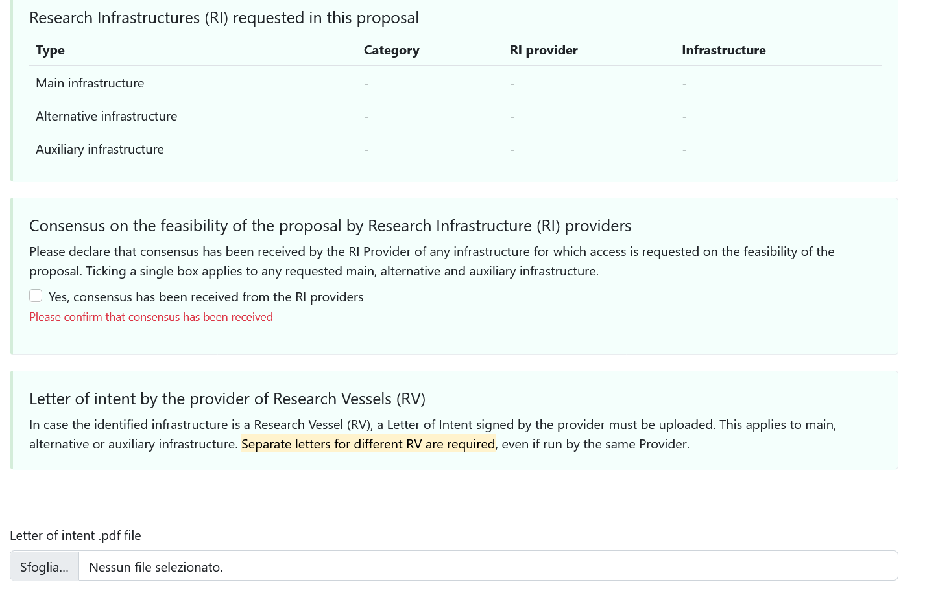

D6. Final declarations, check list and confirmation of submission

I declare that:
▪ In case of physical access to a RI, if applicable, any investigation will be observed and carried out in accordance with the general principles of the 'Code of Conduct for Responsible Marine Research in the Deep Seas and High Seas of the OSPAR Maritime Area', regardless of the area of operation.
▪ If the proposal is successful, I understand and accept to be bound by the user-provider agreement.
▪ The information provided is accurate and correct.

SUBMIT YOUR PROPOSAL!

https://ec.europa.eu/info/funding-tenders/opportunities/docs/2021-2027/common/guidance/how- to-complete-your-ethics-self-assessment_en.pdf
Please note that for access to genetic resources, you must also comply with the Nagoya Protocol on Access and Benefit Sharing and EU Regulation (EU) No 511/2014 which implements this Protocol. You will also have to ascertain towards the competent authorities and focal point that these used genetic resources and traditional knowledge associated with genetic resources have been accessed in accordance with applicable access and benefit-sharing legislation or regulatory requirements, and that benefits are fairly and equitably shared upon mutually agreed terms, in accordance with any applicable legislation or regulatory requirements.
The EU Taxonomy Regulation — adopted in June 2020 and progressively implemented through Delegated Acts — is a key tool to support the transition towards a sustainable, climate-neutral economy. It establishes a science-based classification system to determine whether an economic activity can be considered environmentally sustainable, helping investors, industry, and researchers align with the European Green Deal objectives. For more information: - Research and innovation at the heart of the EU Taxonomy - Research and Innovation and the EU Taxonomy (European Commission, DG RTD, 2021 PDF)

